SPRING APPLICATION
XÂY DỰNG DEMO CHO ỨNG DỤNG SPRING

THUỘC TÍNH TÀI LIỆU
Tiêu đề: Xây dựng demo cho ứng dụng Spring
Chủ đề: Spring application
Tác giả: Laptrinh.vn
Từ khóa: Spring, ibatis

TABLE OF CONTENTS
1. THUẬT NGỮ 3
2. GIỚI THIỆU 3
3. XÂY DỰNG ỨNG DỤNG 3
3.1. Dynamic Web project 3
3.1.1. Create java web application 3
3.1.2. Xây dựng controller 5
3.1.3. Cấu hình thư mục jsp 6
3.1.4. Sử dụng Sitemap 6
3.2. Connect Database 9
3.2.1. Sử dụng iBatis 9
3.3. Displaytag, jstl & một số thư viện khác 13

THUẬT NGỮ
This section is intentionally left blank

GIỚI THIỆU

XÂY DỰNG ỨNG DỤNG

Dynamic Web project

Create java web application
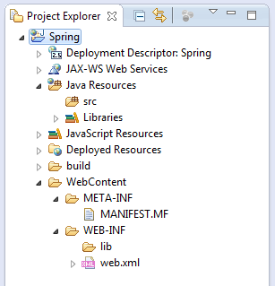
Sử dụng thư viện Spring
Download: http://www.springsource.org/spring-framework
Copy vào thư mục lib
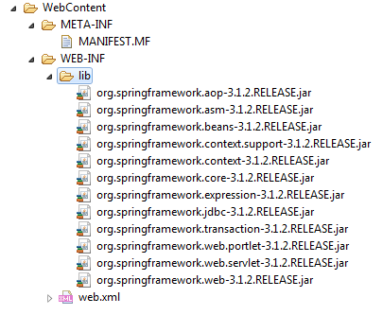
Thêm 2 thư viện để ghi log
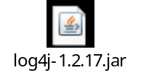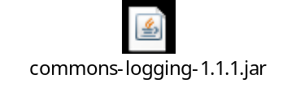
Chỉnh sửa file WEB-INF\web.xml
<?xml version="1.0" encoding="UTF-8"?>
<web-app xmlns:xsi="http://www.w3.org/2001/XMLSchema-instance"
xmlns="http://java.sun.com/xml/ns/javaee" xmlns:web="http://java.sun.com/xml/ns/javaee/web-app_2_5.xsd"
xsi:schemaLocation="http://java.sun.com/xml/ns/javaee http://java.sun.com/xml/ns/javaee/web-app_2_5.xsd"
id="WebApp_ID" version="2.5">
<display-name>Spring</display-name>

<servlet>
<servlet-name>dispatcher</servlet-name>
<servlet-class>org.springframework.web.servlet.DispatcherServlet</servlet-class>
<load-on-startup>1</load-on-startup>
</servlet>
<servlet-mapping>
<servlet-name>dispatcher</servlet-name>
<url-pattern>*.htm</url-pattern>
</servlet-mapping>

<welcome-file-list>
<welcome-file>index.html</welcome-file>
<welcome-file>index.htm</welcome-file>
<welcome-file>index.jsp</welcome-file>
<welcome-file>default.html</welcome-file>
<welcome-file>default.htm</welcome-file>
<welcome-file>default.jsp</welcome-file>
</welcome-file-list>
</web-app>

Thêm file WEB-INF\dispatcher-servlet.xml
<?xml version="1.0" encoding="UTF-8"?>

<beans xmlns="http://www.springframework.org/schema/beans"
xmlns:xsi="http://www.w3.org/2001/XMLSchema-instance" xmlns:p="http://www.springframework.org/schema/p"
xmlns:context="http://www.springframework.org/schema/context"
xsi:schemaLocation="http://www.springframework.org/schema/beans
http://www.springframework.org/schema/beans/spring-beans-3.0.xsd
http://www.springframework.org/schema/context
http://www.springframework.org/schema/context/spring-context-3.0.xsd">

<context:component-scan base-package="springapp.web.controller" />
</beans>

Xây dựng controller
Tạo package springapp.web.controller
Tạo class: HelloController
package springapp.web.controller;

import org.springframework.stereotype.Controller;
import org.springframework.ui.Model;
import org.springframework.web.bind.annotation.RequestMapping;
import org.springframework.web.servlet.ModelAndView;

/**
* Description: Hello controller
* @author DatNH
*
* Detail:
* - @: annotation java
*
*/
@Controller
public class HelloController {

/**
* Nhan request /hello, xu ly thong tin
* @return
*/
@RequestMapping("/hello")
public ModelAndView hello(Model model) {

// set session value
model.addAttribute("name", "DatNH");

return new ModelAndView("hello.jsp");
}

@RequestMapping("/helloworld")
public String helloworld(Model model) {

model.addAttribute("name", "DatNH");

return "hello.jsp";
}
}

Tạo file WebContent/hello.jsp
<html>
<head>
<title>Hello World</title>
</head>
<body>
<h1>Chương trình được xây dựng dựa trên framework MVC Sping 3</h1>
<p>Xin chào: <b>${name}</b></p>
</body>
</html>

Kết quả
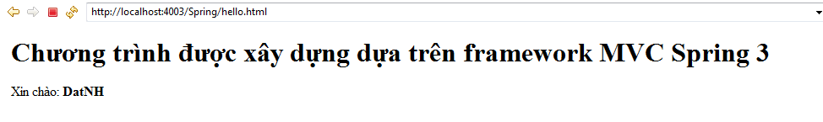

Cấu hình thư mục jsp
Thêm vào file dispatcher-servlet.xml
<bean id="viewResolver"
class="org.springframework.web.servlet.view.InternalResourceViewResolver"
p:prefix="/WEB-INF/jsp/" p:suffix=".jsp" />

Sửa lại file controller
return new ModelAndView("hello");

Tạo thư mục WEB-INF/jsp và copy file hello.jsp vào

Sử dụng Sitemap
Download: http://www.opensymphony.com/sitemesh
Copy lib sitemesh-2.4.x.jar vào thư mục WEB-INF/lib
Thêm filter vào web.xml
<!-- Sitemesh -->
<filter>
<filter-name>sitemesh</filter-name>
<filter-class>com.opensymphony.module.sitemesh.filter.PageFilter</filter-class>
</filter>
<filter-mapping>
<filter-name>sitemesh</filter-name>
<url-pattern>/*</url-pattern>
</filter-mapping>

Tạo một số thư mục trong WebContent/
- decorators : Thư mục gồm tất cả các file decorator (e.g. main.jsp, printable.jsp).
- includes: Thư mục gồm tất cả các file sẽ được include tới các file khác (e.g. header.jsp, footer.jsp, copyright.jsp).
- images: Thư mục bao gồm tất cả các ảnh (e.g. background.gif, logo.gif).
- styles: Thư mục bao gồm tất cả CSS styles (e.g. ie4.css, ns4.css).
- scripts: Thư mục bao gồm tất cả các scripts (JavaScript, VBScript files).
Tạo file WEB-INF/decorators.xml
<?xml version="1.0" encoding="UTF-8"?>

<decorators defaultdir="/decorators">
<decorator name="main" page="main.jsp">
<pattern>/*</pattern>
</decorator>
</decorators>

Tạo file: /includes/header.jsp
<%@ page language="java" contentType="text/html; charset=UTF-8"
pageEncoding="UTF-8"%>

[HEADER]
<hr/>

Tạo file: /includes/footer.jsp
<%@ page language="java" contentType="text/html; charset=UTF-8"
pageEncoding="UTF-8"%>

<hr/>
[FOOTER]

Tạo file: /includes/taglibs.jsp
<%@ taglib prefix="decorator" uri="http://www.opensymphony.com/sitemesh/decorator" %>

Tạo 1 file decorator : /decorators/main.jsp
<%@ page language="java" contentType="text/html; charset=UTF-8" pageEncoding="UTF-8"%>
<%@ include file="/includes/taglibs.jsp"%>

<!DOCTYPE html PUBLIC "-//W3C//DTD HTML 4.01 Transitional//EN" "http://www.w3.org/TR/html4/loose.dtd">
<html>
<head>
<title>[springapp] <decorator:title/> </title>
</head>
<body>
<div id="container">
<%@ include file="/includes/header.jsp"%>
<div id="content">
<decorator:body />
</div>
<%@ include file="/includes/footer.jsp"%>
</div>
</body>
</html>

Kết quả
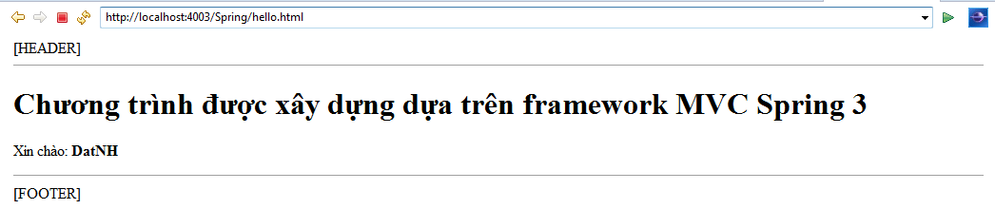
Cấu trúc project
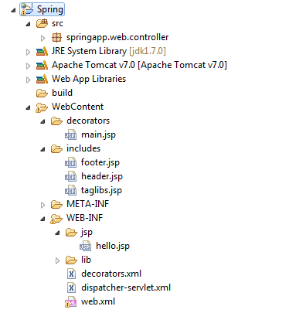

Connect Database
Tải thư viện JDBC driver phù hợp, ở đây dùng MySQL
Tạo file context.xml trong META-INF
<?xml version="1.0" encoding="UTF-8"?>

<Context>
<Resource
name="jdbc/SpringMySqlDS"
auth="Container"
type="javax.sql.DataSource"
driverClassName="com.mysql.jdbc.Driver"
url="jdbc:mysql://localhost:3306/spring"
removeAbandoned="true"
maxActive="75"
maxIdle="30"
maxWait="-1"
username="root"
password="nguyendat"
validationQuery="select 1 from dual"
/>

</Context>

Sử dụng iBatis
Download: http://code.google.com/p/mybatis/
Project | Description | Links
MyBatis 3 | SQL Mapping Framework for Java | download | docs
Generator | Code generator for MyBatis and iBATIS | download | docs

Trong web.xml, tạo một reference tới resource SpringMySqlDS
<resource-ref>
<description>Chat Datasource</description>
<res-ref-name>jdbc/SpringMySqlDS</res-ref-name>
<res-type>javax.sql.DataSource</res-type>
<res-auth>Container</res-auth>
</resource-ref>

Tạo các package
- springapp.core.dao
- springapp.core.dao.xml
- springapp.core.model
- springapp.core.service
Copy mybatis-3.2.0-SNAPSHOT.jar vào WEB-INF/lib
Tạo file mybatisConfig.xml trong springapp.core.dao.xml
Cấu hình environments:
<configuration>
<environments default="development">
<environment id="development">
<transactionManager type="MANAGED">
<property name="closeConnection" value="true" />
</transactionManager>
<dataSource type="JNDI">
<property name="data_source" value="java:comp/env/jdbc/SpringMySqlDS" />
</dataSource>
</environment>
</environments>
</configuration>

Tạo file mapping database table và java class
- Khai báo và mapping column table với thuộc tính trong java
- Thực hiện câu lệnh generator
cd /d C:\Users\Phoenix\workspace\juno\Spring\generator\ (tùy thư mục nhé)
java -jar mybatis-generator-core-1.3.1.jar -configfile generatorConfig.xml -overwrite -tables user

Các class đã được generator
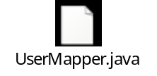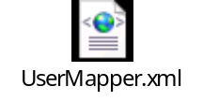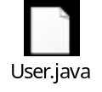
Xử lý dữ liệu
- Tạo service class
  - Interface: UserServiceLocal.java
  - Class: UserService
- Tạo bean cho UserService
  - File web.xml
Thêm cấu hình applicationContext.xml
<context-param>
<param-name>contextConfigLocation</param-name>
<param-value>
/WEB-INF/applicationContext.xml
</param-value>
</context-param>
<listener>
<listener-class>org.springframework.web.context.ContextLoaderListener</listener-class>
</listener>

  - File applicationContext.xml
Application context: Khai báo các bean session sử dụng trong chương trình.
<?xml version="1.0" encoding="UTF-8"?>
<beans xmlns="http://www.springframework.org/schema/beans"
xmlns:xsi="http://www.w3.org/2001/XMLSchema-instance"
xmlns:jee="http://www.springframework.org/schema/jee"
xmlns:p="http://www.springframework.org/schema/p"
xsi:schemaLocation="http://www.springframework.org/schema/beans
http://www.springframework.org/schema/beans/spring-beans-3.1.xsd
http://www.springframework.org/schema/jee
http://www.springframework.org/schema/jee/spring-jee-2.5.xsd">

<bean id="userService" class="springapp.core.service.UserService" />

</beans>

  - File myBatisConfig.xml
<mapper resource="springapp/core/dao/xml/UserMapper.xml" />

- Xử lý Controller
  - File UserController.java
package springapp.web.controller;

import org.springframework.beans.factory.annotation.Autowired;
import org.springframework.stereotype.Controller;
import org.springframework.ui.Model;
import org.springframework.web.bind.annotation.RequestMapping;

import springapp.core.model.User;
import springapp.core.service.UserServiceLocal;

/**
* User controller
* @author DatNh
*
*/
@Controller
public class UserController {

@Autowired
private UserServiceLocal userService;

@RequestMapping("/user")
public String helloworld(Model model) {

User user = userService.selectByPrimaryKey(1);

model.addAttribute("user", user);

return "user";
}
}

  - File user.jsp
<%@ page language="java" contentType="text/html; charset=UTF-8" pageEncoding="UTF-8"%>

<html>
<head>
<title>Hello World</title>
</head>
<body>
<h1>User demo</h1>
<p>Xin chào: <b>${user.username}</b></p>
</body>
</html>

  - File UserServiceLocal.java
package springapp.core.service;

import springapp.core.model.User;

/**
*
* @author DatNH
*
*/
public interface UserServiceLocal {

User selectByPrimaryKey(int id);
}

  - File UserService.java
package springapp.core.service;

import org.apache.ibatis.session.SqlSession;
import org.apache.ibatis.session.SqlSessionFactory;

import springapp.core.dao.UserMapper;
import springapp.core.model.User;

/**
* User service
* @author DatNH
*
*/
public class UserService implements UserServiceLocal {

@Override
public User selectByPrimaryKey(int id) {
SqlSessionFactory sqlMapper = MyBatisService.getSessionFactory();
SqlSession sqlSession = sqlMapper.openSession(true);

UserMapper mapper = sqlSession.getMapper(UserMapper.class);

User user = mapper.selectByPrimaryKey(id);

sqlSession.close();

return user;
}
}

Displaytag, jstl & một số thư viện khác
Copy thư viện
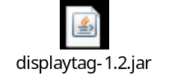
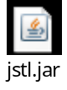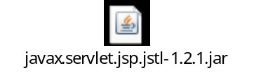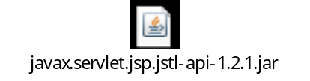
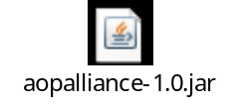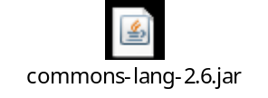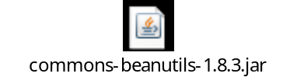
File taglibs.jsp
@RequestMapping("/user/list")
public String list(Model model) {

List<User> userList = userService.getAll();

model.addAttribute("userList", userList);

return "userList";
}

File UserServiceLocal.java
List<User> getAll();

File UserService.java
@Override
public List<User> getAll() {
SqlSessionFactory sqlMapper = MyBatisService.getSessionFactory();
SqlSession sqlSession = sqlMapper.openSession(true);

UserMapper mapper = sqlSession.getMapper(UserMapper.class);

List<User> userList = mapper.getAll();

sqlSession.close();

return userList;
}

File UserMapper.java
List<User> getAll();

File UserMapper.xml
<select id="getAll" resultMap="BaseResultMap">
select
<include refid="Base_Column_List" />
from user
</select>

File userList.jsp
<%@ page language="java" contentType="text/html; charset=UTF-8" pageEncoding="UTF-8"%>
<%@ include file="/includes/taglibs.jsp"%>

<html>
<head>
<title>Hello World</title>
</head>
<body>
<h1>User List</h1>

<div>
<display:table name="${userList}" class="simple wid100" id="user" requestURI="" pagesize="15">
<display:column title="STT" class="stt" > <c:out value="${user_rowNum}"/> </display:column>
<display:column title="Username" property="username" />
<display:column title="Password" property="password"/>
<display:column title="Timestamp" property="timestamp"/>
<display:column title="Create Date" property="createDate" format="{0,date,dd/MM/yyyy HH:mm:ss}" />
</display:table>
</div>
</body>
</html>

Kết quả
